Wildfire Detection: Web Page Design Notes

1-Simple Web Page

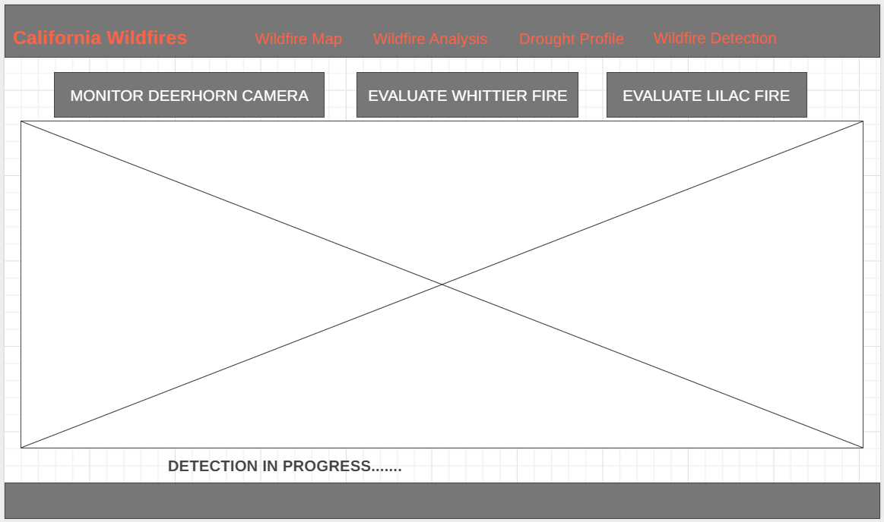

2-User Interaction Scenario: Monitor Deerhorn Camera

1. User clicks on “Monitor Deerhorn Camera” button
2. Latest image from Deerhorn camera is displayed
   1. Along with “Detection in progress…..” message
3. If the model detected any frame(s) with smoke, display a red box around that frame(s) in the image
   1. Along with message “Potential wildfire detected!”
4. If the model did not detect any frame(s) with smoke, display message “No signs of wildfire detected.”
5. If user wants to continue to monitor, they click the button again
   1. If this were more than a simple prototype we would have it monitor automatically and notify the user…..but for our project demonstration I think this is fine.

3- User Interaction Scenario: Evaluate Historical Fire Sequence

1. User clicks on “Evaluate Whittier(tbd) Fire” button
2. First image( from our curated sequence of images from the beginning of that fire) is displayed
   1. Along with “Detection in progress….” Message
3. Same as #3 in above scenario
4. Same as #4 in above scenario
5. Pop up “Click next to continue” button.
   1. If user presses this, the next image in the fire sequence is is displayed (steps #2-5 repeated).